MEGR 3122 Dynamics Systems II

Catalog Data: MEGR 3122 Dynamics Systems II (3)
Modeling of dynamic systems. Dynamic response of first and second order systems due to various inputs and initial conditions. Introduction to automatic controls.

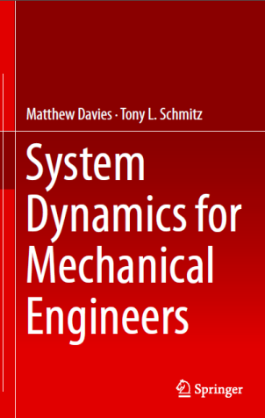
Textbook(s): System Dynamics for Mechanical Engineers., Matthew Davies and Tony L. Schmitz, ISBN: 978-1-4614-9292-4, ©2014, Springer, New York. (Free download link available on course website.)

Goals: The objective of this course is to provide students with an introduction to dynamic system modeling and analysis.

Prerequisites: MEGR 3121 and MATH 2171, both with a grade of C or better.

Topics: Review of Linear Ordinary Differential Equations
Laplace Transforms and System Transfer Functions
Inverse Laplace Transforms Using Partial Fraction Expansions
First Order Response
Second Order Response
Modeling of Lumped Parameter Mechanical Systems
Modeling of Electrical, Thermal and Fluid Systems (Mechatronics)
Frequency Response, Introduction to Vibrations

Outcomes/Objectives: The successful student will be competent in the following:
- Obtain differential equation models of mechanical systems based on free-body diagrams.
- Obtain the response of first and second order systems due to initial conditions and various forcing. functions such as step, ramp and sinusoidal.
- Solve first and second order linear systems using Laplace transforms.
- Develop lumped parameter models of dynamic systems.
- Use Matlab® for dynamic simulations.

Computer Usage: Matlab® will be used in this course to simulate system response and solve systems of equations that model mechanical systems. The class also uses online course software.

Follow-up Courses: A grade of “C” or better is required to obtain a degree in Mechanical Engineering.

Grading: Three Exams: 15% each
Cumulative Final Exam: 30%
Online Learning Content and Written Homeworks: 25%
Only NCEES (FE Exam) approved calculators are allowed on exams (see http://ncees.org/exams/calculator-policy/ ).

Academic Conduct: Students have the responsibility to know and observe the requirements of the UNC Charlotte Code of Student Academic Integrity (http://www.legal.uncc.edu/policies/ps-105.html). This code forbids cheating, fabrication or falsification of information, multiple submissions of academic work, plagiarism, abuse of academic materials, and complicity in academic dishonesty.

Professor: Dr. Amir H. Ghasemi, Motorsport 106, Phone: 704-687-7017, Office Hours: W/F: 10:00 am – 11:00am (Zoom). Online or Open SI Sessions will be scheduled as required. MATLAB® reviews & exam review sessions will also be scheduled as appropriate.

Class Improvement
Committee: A volunteer class improvement committee will be implemented in this class.

